Low Level Design – FHTC Module
Project: Jal Rekha
Module: FHTC – Functional Household Tap Connection

1. Introduction

The FHTC Mobile App is a field-utility tool designed for Field Engineers (FE) to execute household surveys and record tap installations under the Jal Jeevan Mission. It supports offline data capture and geo-tagged verification to ensure transparency in rural water connectivity.

2. System Architecture Overview
2.1 Technology Stack
- Mobile Application: Android (Core Java/Kotlin)
  - Offline Sync using SQLite / Local Storage
- Backend: RESTful WCF Services (.NET)
- Storage: Local SQLite database for offline mode/drafts.
- External APIs: Google Maps API for geo-tagging and reverse geocoding.

2.2 User Role
- Field Engineer (FE): Primary user for mobile-based surveys and installations.

2.3 Infrastructure & Security
- Web Server: IIS
- Authentication: JWT Tokens
- Authorization: Role-Based Access Control (RBAC)

Hosting: In-House Cloud
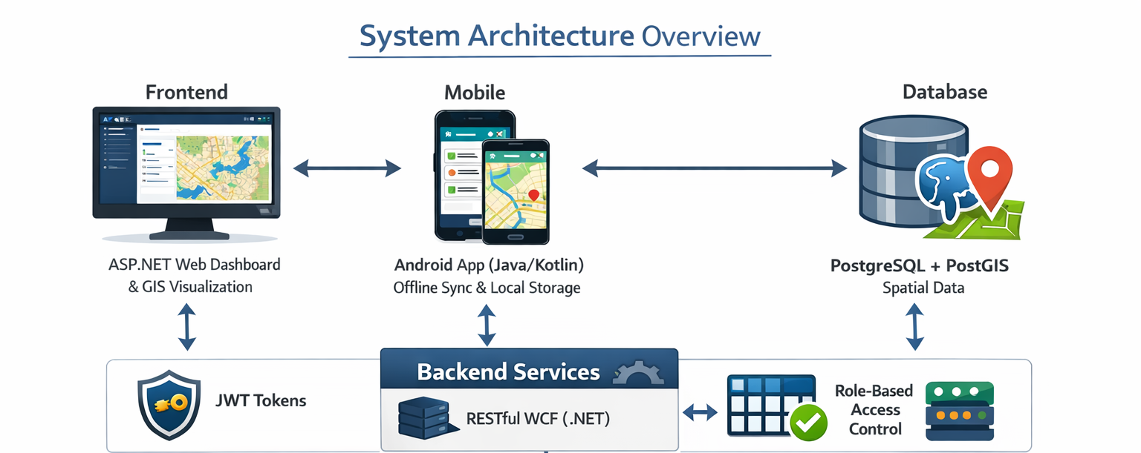

3. Screen-Level Specifications

3.1 Main Dashboard (HSC Survey)
- Functionality: Central navigation hub for field activities.
- Key Modules:
  - Download: Fetch village/household data for offline use.
  - HSC Verification: Launch the primary survey/installation form.
  - Sync Offline Data: Push locally saved records to the central server.
  - View/Delete Draft: Manage incomplete survey entries.

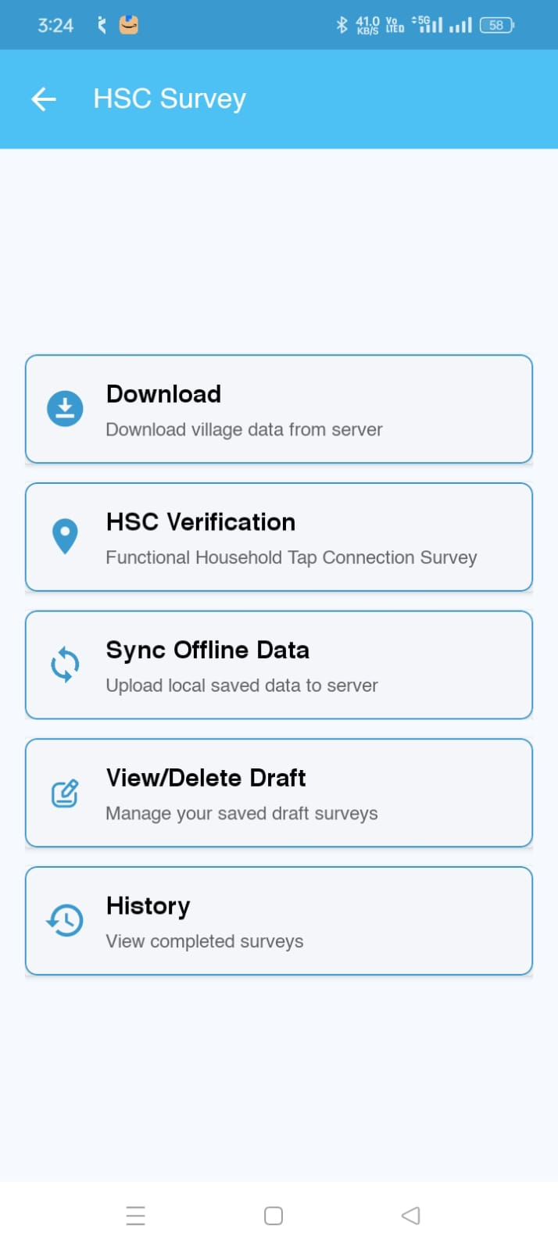
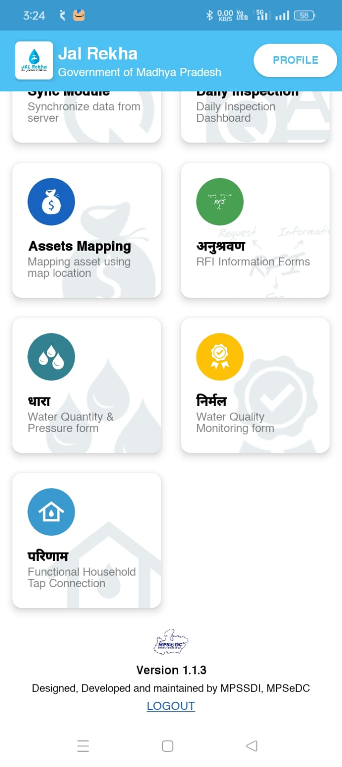
  - History: View logs of successfully submitted surveys.

3.2 Household Selection & Survey
- Data Retrieval: Filters include Scheme, District, Block, Gram Panchayat, and Village.
- Search Engine: Allows FE to find beneficiaries by Name, Mobile Number, Family ID, or Member ID.
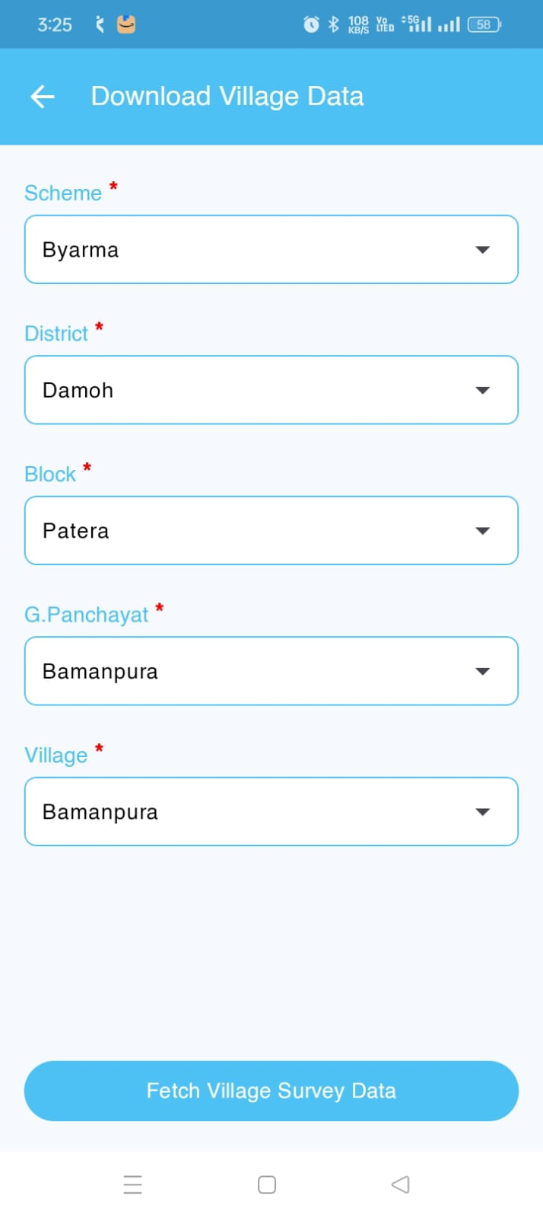
- Validation: Uses Samagra Family ID to prevent duplicate entries.

3.3 Tap Installation & Verification Form
- Geo-Fencing: Captures GPS coordinates; must be within 50 meters of the registered household.
- Visual Evidence: Mandatory photo upload of the water tap connection with the beneficiary.
- Field Inputs:
  - Connection Location (Inside/Outside Premise).
  - Installation Status (Accepted/Rejected).
  - Installation Quality (Check for Low Pressure, Pipe Leaks, or Defective Taps).


4. Logical Workflows

4.1 Field Survey Workflow
- Start: FE logs into the mobile app.
- Preparation: Download village data for the assigned area.
- Survey: Conduct household survey and capture GPS/Photos.
- Action: Install tap connection.
- Submission: * If successful: Submit readings and photos to the portal.
  - If failed (e.g., Leak/Low Pressure): Mark as failed and record reasons in the database.
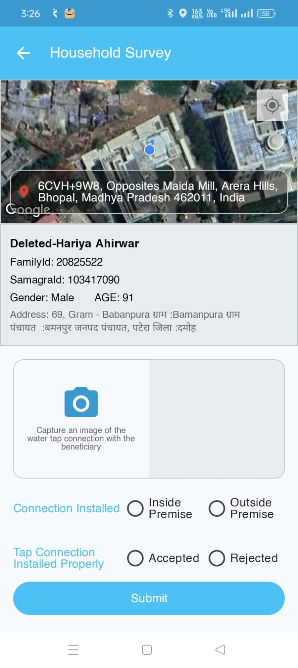

4.2 Offline Data Management
- Draft State: If connectivity is lost, data is saved as a "Draft".
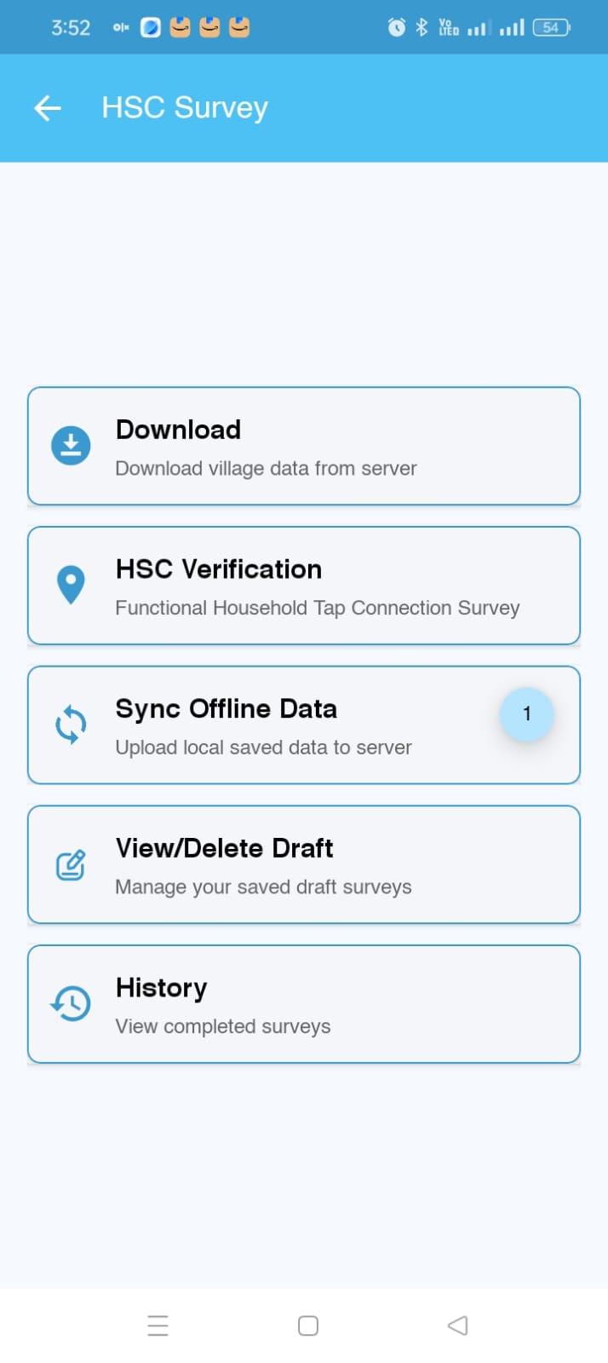
- Synchronization: Once network is available, the FE manually triggers "Sync Offline Data" to upload records via JWT-secured endpoints.

5. FHTC Process Flow
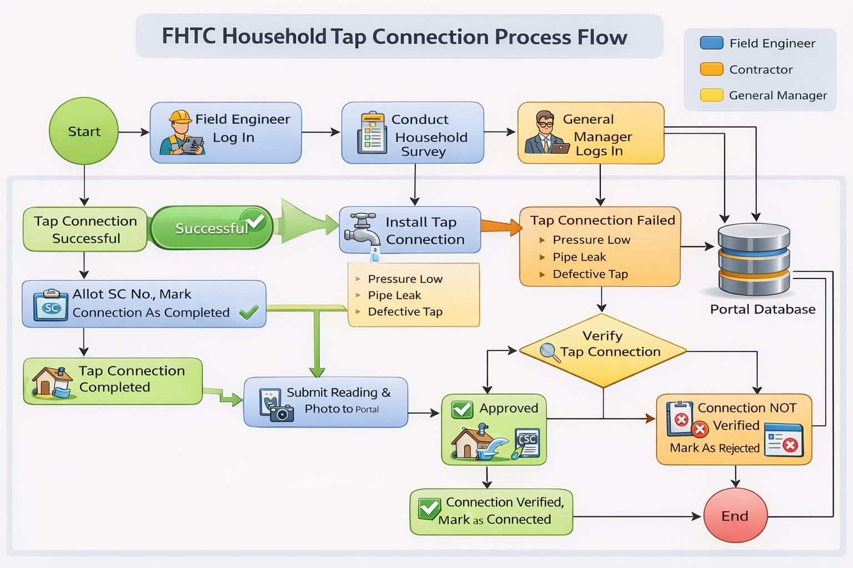

6. Error Handling & Validation Rules
- GPS Block: Submission is strictly blocked if GPS data is missing.
- Mandatory Fields: All survey fields and at least one photo are required for submission.
- Network Resilience: The app must support an offline mode to accommodate remote rural areas.
- Re-submission: Connections rejected by the GM can be re-accessed and re-submitted after addressing specific rejection reasons.

7. Conclusion
The FHTC Module follows a mobile-assisted and web-governed architecture ensuring accurate data capture, supervisory control, and reliable reporting for Tap Connection monitoring under Jal Rekha.

